7.87: a) Eliminating in favor of and 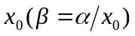,
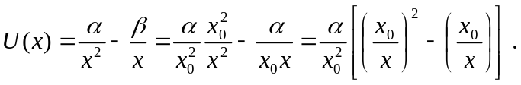
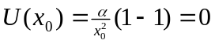. 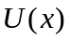 is positive for 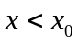 and negative for 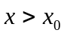 ( and must be taken as positive).

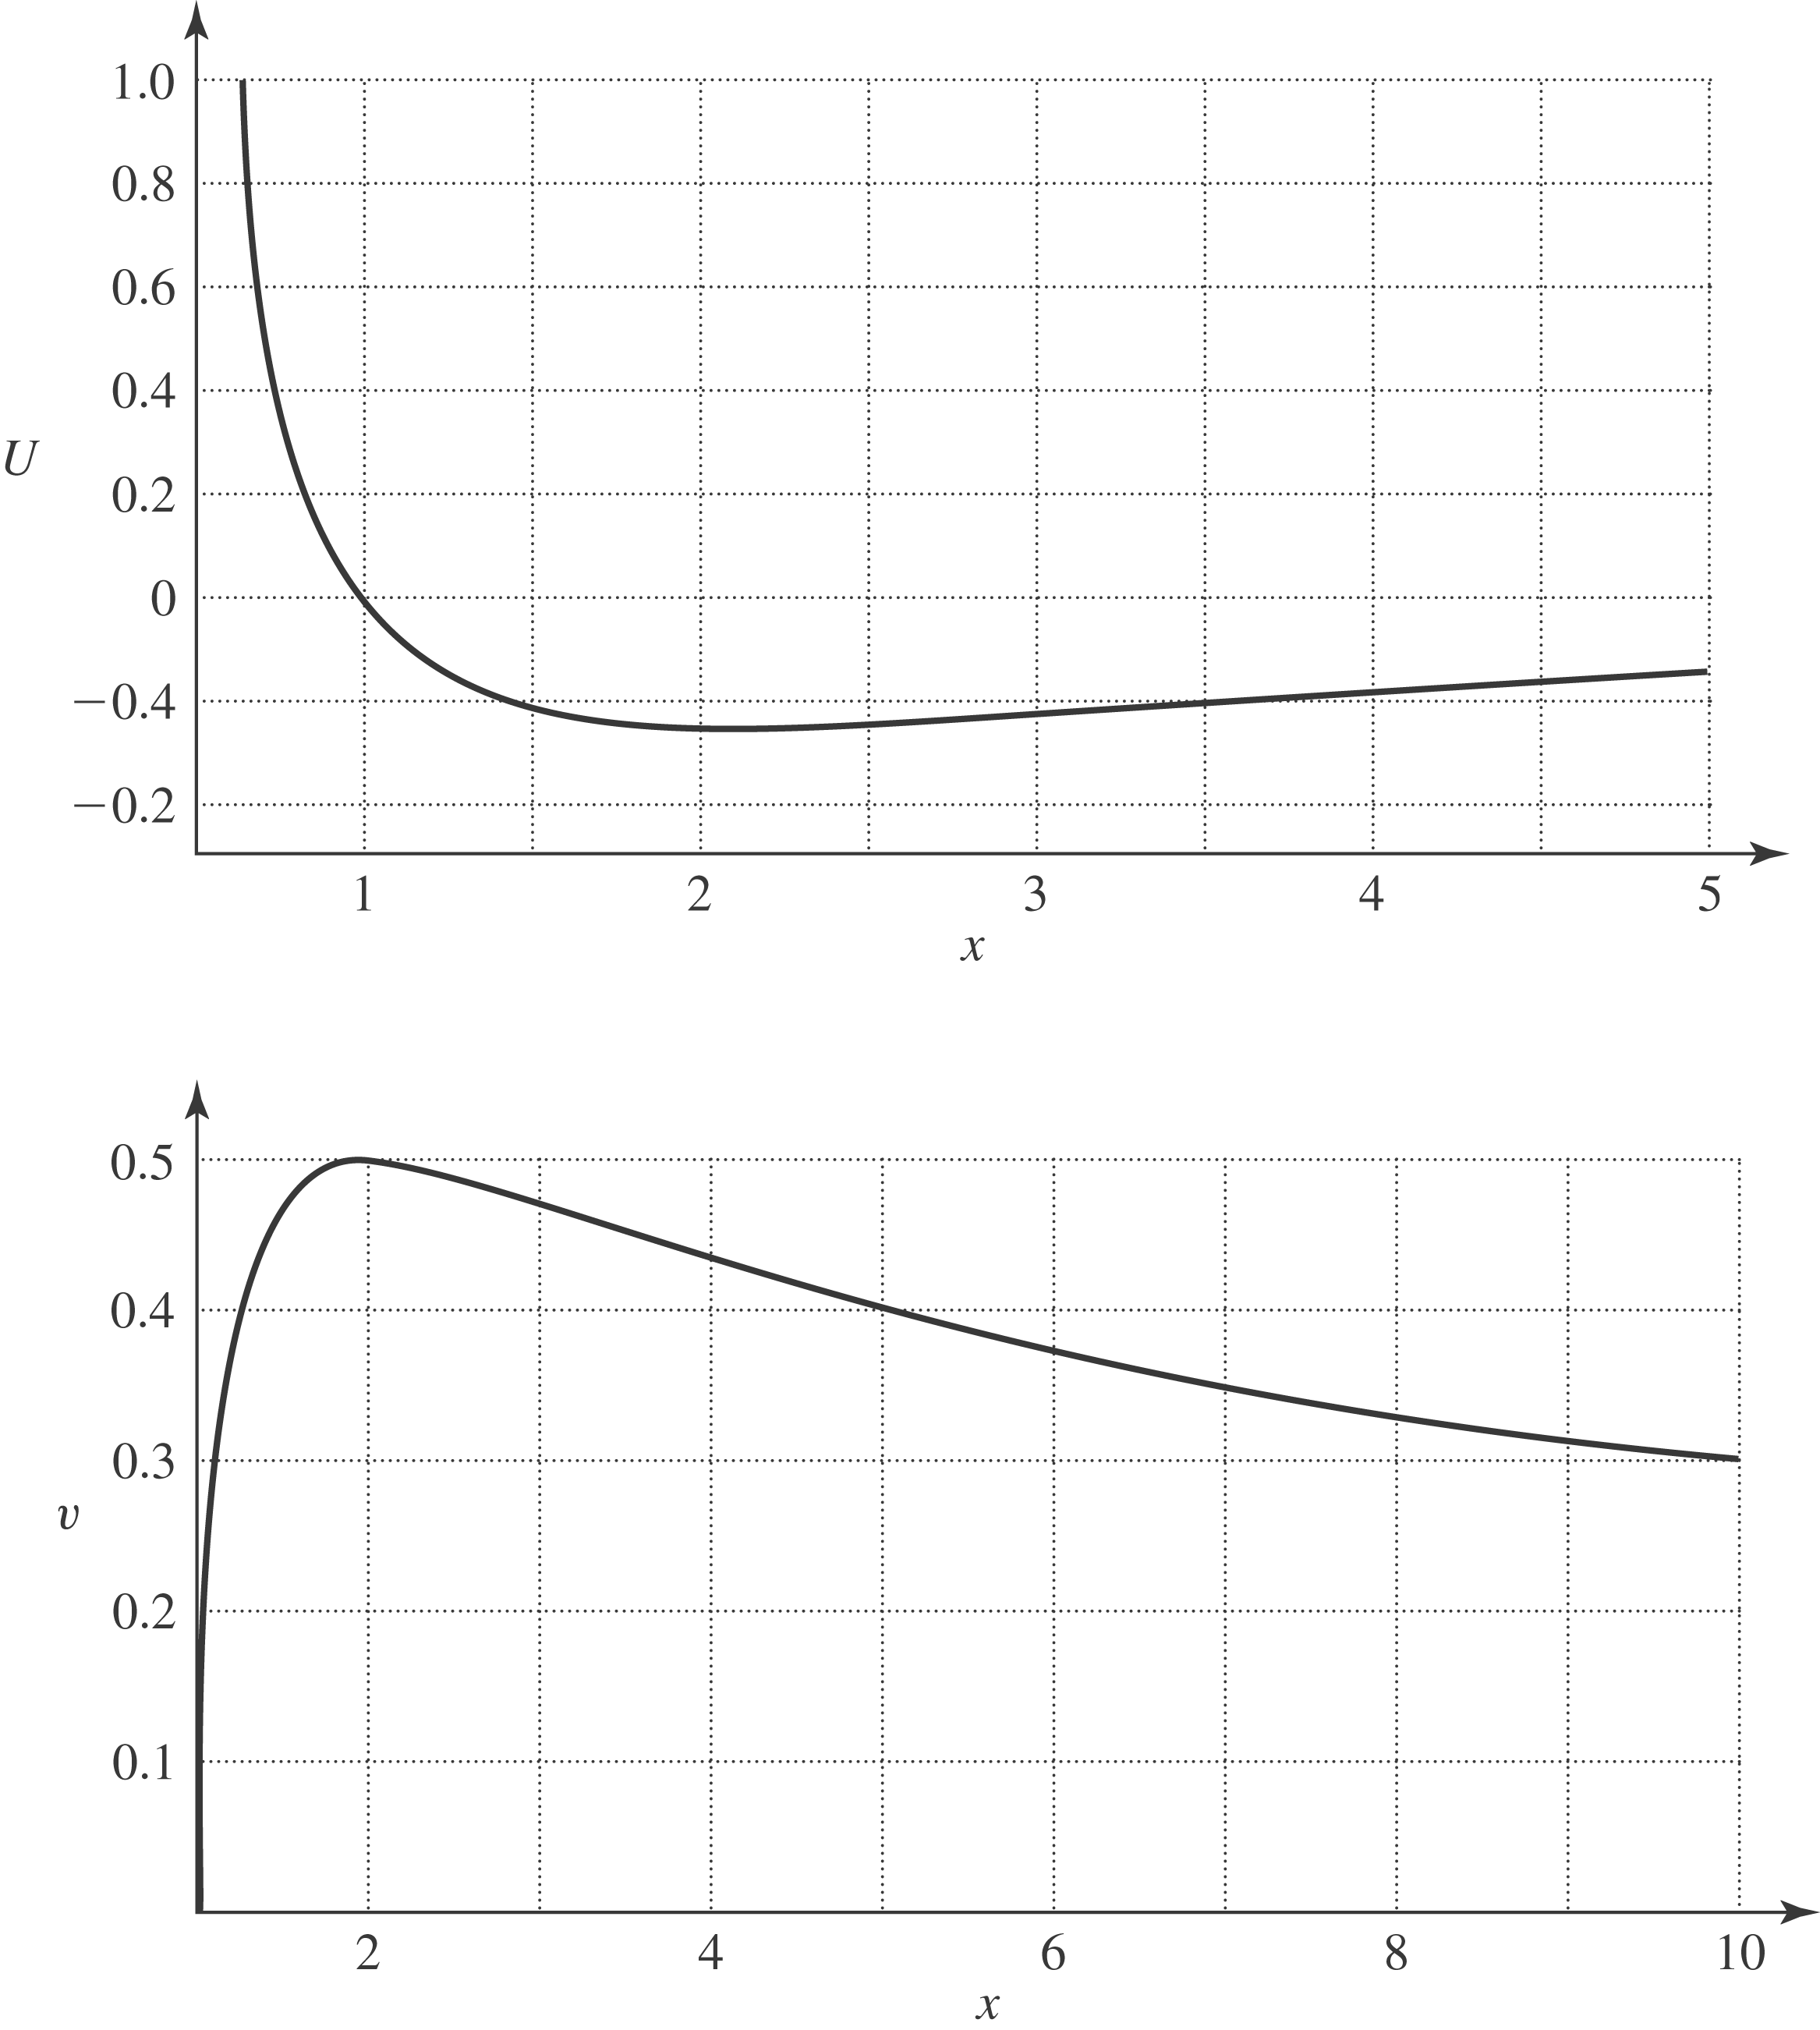
b)
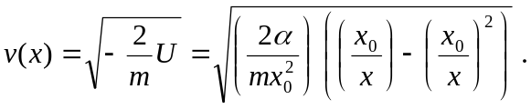
The proton moves in the positive x-direction, speeding up until it reaches a maximum speed (see part (c)), and then slows down, although it never stops. The minus sign in the square root in the expression for 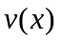 indicates that the particle will be found only in the region where 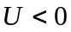, that is, .
c) The maximum speed corresponds to the maximum kinetic energy, and hence the minimum potential energy. This minimum occurs when 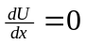, or
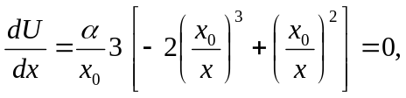
which has the solution 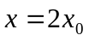. 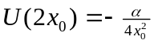, so 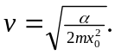 d) The maximum speed occurs at a point where , and from Eq. (7.15), the force at this point is zero. e) 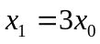, and 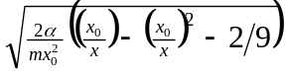. The particle is confined to the region where 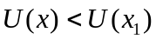. The maximum speed still occurs at , but now the particle will oscillate between  and some minimum value (see part (f)). f) Note that 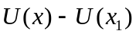 can be written as
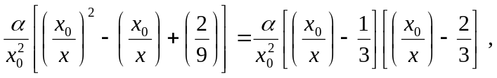
which is zero (and hence the kinetic energy is zero) at 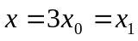 and 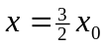. Thus, when the particle is released from 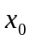, it goes on to infinity, and doesn’t reach any maximum distance. When released from , it oscillates between 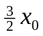 and 

